Task 1: Star, Bus and Mesh Topologies

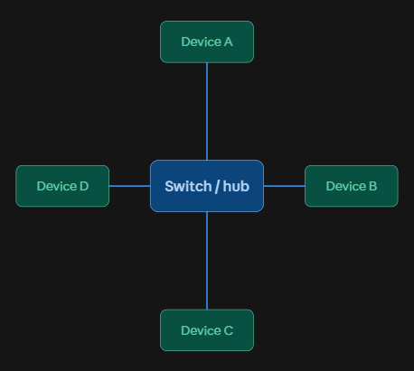
Star Topology
- Every device connects individually to a central switch.
- A real-world example is WhatsApp: all users connect
to central servers (not directly to each other), so the
server acts like the hub, keeping message routing and
delivery centrally controlled and easy to manage.

Bus Topology

All devices share one common cable like SDI/coaxial (the backbone). This maps well to older cable/ DTH TV distribution networks, IPL Live Streaming on JioCinema / Hotstar (Broadcast Distribution Line) where a single trunk line carries the signal and every household simply taps into it — cheap to lay out, but if the main cable is cut, everyone downstream loses signal.
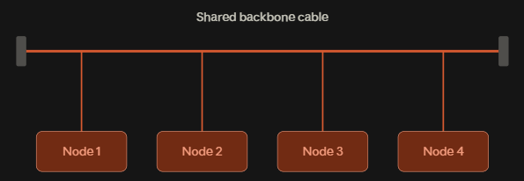

Mesh Topology

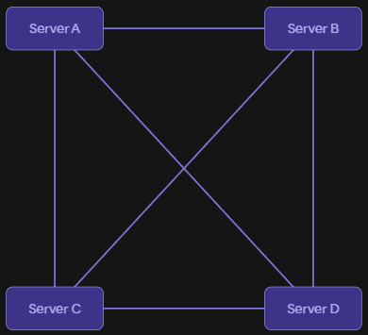
Every node connects directly to every other node, so there's
no single point of failure. This fits large-scale streaming during I
PL matches, Flipkart / Amazon CDN & Logistics Backbone:
video/data is served from multiple interconnected data
centers/CDN nodes, so if one node goes down or gets
overloaded, traffic reroutes through another, keeping the
stream alive for millions of viewers.

Task 2: Comparison of Network Topologies

Topology | Pros | Cons | Best Use Case | Example
Star | 1. Easy to install 2. Easy to troubleshoot  3. Failure of one device does not affect others  4. Easy to expand | 1. Requires central switch  2. Switch failure affects entire network  3. More cables required  4. Higher cost than bus | Offices, schools, homes | Instagram
Bus | 1. Low cost  2. Uses less cable 3. Simple design 4. Easy for small networks | 1. Main cable failure affects network  2. Difficult troubleshooting 3. Performance decreases with more devices  4. Limited expansion | Small/temporary networks | Small file-sharing network
Ring | 1. Data travels in an organized way 2. No central switch required 3. Equal access for devices  4. Predictable performance | 1. One break can affect communication 2. Difficult troubleshooting 3. Adding devices can be difficult  4. Less flexible | Specialized/older network systems | Office communication network
Mesh | 1. Very reliable  2. Multiple paths available  3. Good fault tolerance  4. High availability | 1. Expensive  2. Requires many connections  3. Complex installation  4. Difficult to maintain | Critical and high-reliability networks | Online gaming/server infrastructure

Task 3: Topology for a multiplayer game like PUBG/Free Fire

I’d choose a centralized Star topology ensures that every mobile player connects directly to an authoritative regional game server rather than connecting to peer devices. This setup minimizes packet latency (ping) and prevents desynchronization, as the central server remains the single source of truth for player positions and hit registration. While deploying high-capacity central servers increases infrastructure costs, it provides reliable anti-cheat protection and prevents client-side link failures from disrupting other players.

Task 4: Warehouse network recommendation

I'd recommend star topology here: A Star topology centered around a small 16-port Gigabit switch is inexpensive to set up using standard Cat6 cables. It's cost-effective for a small network of just 8 nodes, makes troubleshooting easy (If an individual workstation cable is damaged on the warehouse floor, only that specific terminal goes down while the remaining seven stations continue scanning inventory and processing orders uninterrupted), and scales well if the warehouse adds more computers later, since you just plug into a free switch port.

